3.2 I can reflect on the efficiency of project management techniques

The Agile project management is increasingly preferred over other project management methodologies, for its efficiency. An Agile project management methodology can help to deliver a project faster than others. There are several incremental steps in this project management methodology to achieve the ultimate goal and a quality end product. While other traditional methodology attempt to complete the project within a stipulated time and budget, but don’t allow for change in business requirement frequently in the middle of the project progress, the Agile project management method allows for changes at any point of the project and as many times as needed, making it more efficient in delivering a product that would have less errors and be of good quality. With the Agile method, clients are involved in the delivery process of the project and can request changes, this ensures the result of final product is according to the customer’s requirement, this prevents last minute costly changes.

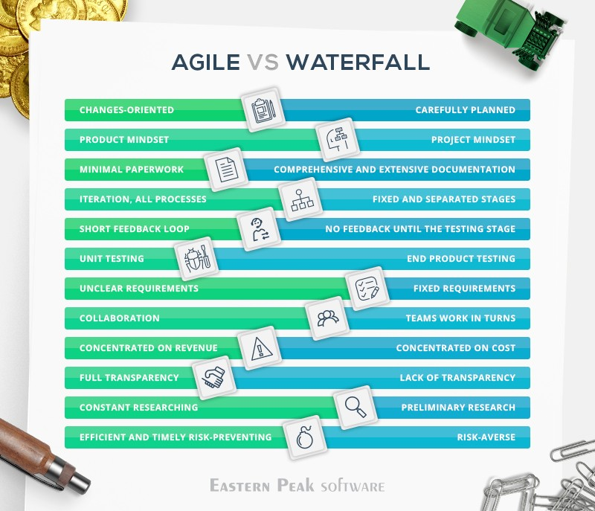 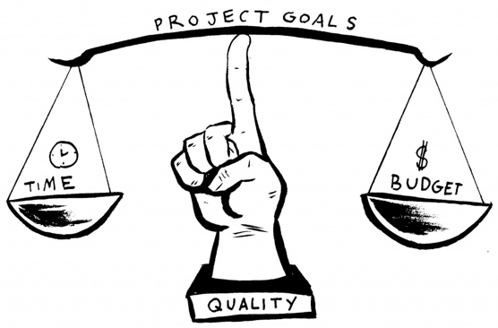

Easternpeak.com